Wunderschöne Babys
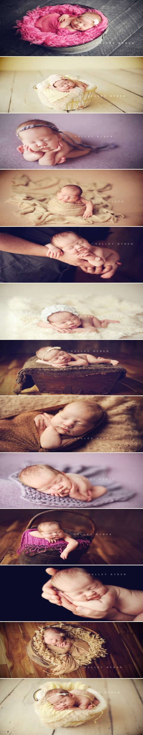
http://pinterest.com/pin/177118197816690054/

